**9. ReactJS-HOL**

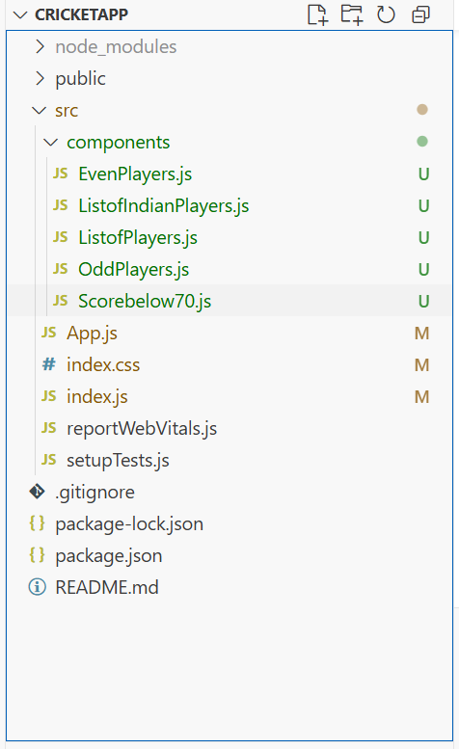

**ListofPlayers.js**  
  
import React from 'react';

function ListofPlayers({ players }) {

  return (

    <div>

      {players.map((item, index) => (

        <li key={index}>Mr. {item.name} <span>{item.score}</span></li>

      ))}

    </div>

  );

}

export default ListofPlayers;

**ListofIndianPlayers.js**  
import React from 'react';

function ListofIndianPlayers({ IndianPlayers }) {

  return (

    <ul>

      {IndianPlayers.map((item, index) => (

        <li key={index}>{item}</li>

      ))}

    </ul>

  );

}

export default ListofIndianPlayers;

**OddPlayers.js**  
import React from 'react';

function OddPlayers([first, , third, , fifth]) {

  return (

    <ul>

      <li>First : {first}</li>

      <li>Third : {third}</li>

      <li>Fifth : {fifth}</li>

    </ul>

  );

}

export default OddPlayers;

**EvenPlayers.js**  
import React from 'react';

function EvenPlayers([, second, , fourth, , sixth]) {

  return (

    <div>

      <li>Second : {second}</li>

      <li>Fourth : {fourth}</li>

      <li>Sixth : {sixth}</li>

    </div>

  );

}

export default EvenPlayers;

**Scorebelow70.js**  
  
import React from 'react';

function Scorebelow70({ players }) {

  const filteredPlayers = players.filter(player => player.score <= 70);

  return (

    <div>

      {filteredPlayers.map((item, index) => (

        <li key={index}>Mr. {item.name} <span>{item.score}</span></li>

      ))}

    </div>

  );

}

export default Scorebelow70;

